**Software Requirements and Design Document**

**For**

**Group 2**

Version 2.0

**Authors**:

Melanie B

Harrison G

Julio S

Alora C

Jacob P

# Overview (5 points)

The Labyrinth is a puzzle-solving game following an individual who has passed away, but is unaware of their passing. The goal of the user is to escape from a strange, unknown house by traversing the environment, solving challenging puzzles, and learning the truth about their situation. The puzzles in the game are opened based on exploring different objects in the room that follow the user’s life. The user will then use this knowledge and items found to unlock different areas of the house while slowly piecing together their situation in order to find the way out, and into the next plane of existence.

The game consists of five rooms with puzzles and a final area where the game ends. The game begins in the living room which leads to the loft on the left, the bedroom in the center, and the kitchen on the right. From the living room, you can unlock the doors to the bedroom and kitchen. In the bedroom, you can unlock the door to the loft (located in the living room) via the TV puzzle. You can also unlock the door in the bedroom which leads to the bathroom with the lock puzzle. Within the kitchen, a hint to unlocking the final area is given via the fridge magnet anagram.

# Functional Requirements (10 points)

1. System should allow users to enter the scene and click on the objects in the room in order to open different puzzles and find clues. (High)
2. When the letter object is pressed, an image with the contents of the letter should be displayed. (Low)
3. When the clock object is pressed, the image of the clock should expand allowing the user to select the hands in order to change the time. (Medium)
4. While the clock interface is expanded, when the hour hand is clicked, it should move clockwise to the next hour. When the minute hand is clicked, it should move clockwise by 5 minutes. (Medium)
5. When the hands are moved to the correct time, the game should close out of the clock and the right door should unlock. The clock will then be locked at the correct time (10:30), signifying that the user has entered the correct answer and the puzzle is finished. (High)
6. When the newspaper is pressed, the newspaper image should expand allowing the user to read the newspaper in order to search for clues. (Low)
7. When the padlock is pressed, the full image of the padlock should appear to allow the user to interact with it. (Medium)
8. When numbers are pressed on the padlock, they should appear on the padlock’s screen above the numbers. (Low)
9. When the correct numbers are entered, the game should close out of the padlock and have it disappear from the door, signifying it has been unlocked and the user has gotten the puzzle correct. (High)
10. When the user wants to exit a puzzle or image, they can select ‘x’ inside the red circle in the upper right corner; this should close the puzzle or image. (Medium)
11. No other objects in the room should do anything when clicked or pressed. (Low)
12. After a door is unlocked, clicking on the door should allow the user to move to another room/scene. (High)
13. In the kitchen, when the fridge is clicked, an enlarged image of the fridge should appear and allow the user to click on the magnets to solve the anagram. (Medium)
14. When the anagram is solved, the expanded interface should automatically close out and the fridge sprite should be replaced with the solved fridge sprite. The solved fridge sprite will have the magnets spelling out “FIREMAN”. (Medium)
15. When a magnet is clicked, the letter clicked should appear in the thought bubble below the magnets. (Low)
16. When the anagram is solved, if the user clicks on the fridge again, the thought bubble should still say “FIREMAN.” (Low)
17. When the user clicks on one of the tall cabinets on the wall in the kitchen, an image of rotten food in the cabinet will be displayed. (Low)
18. When the user clicks on cabinets under the sink, an image of cleaning products will be displayed. (Low)
19. For the bedroom, when the TV is clicked, an enlarged image of the TV should appear to allow the user to interact with it. (Medium)
20. While the TV interface is enlarged, when the knobs on the TV are clicked, the knobs should rotate counter-clockwise to allow the user to set the proper “Volume” and “Channel” on the TV. (Medium)
21. When the knobs are set to the correct settings, the TV should display the correct channel to show the player solved the puzzle. (Low)
22. When the grieving card is clicked, the inside of the card should be displayed showcasing the contents of the card as well as the pictogram clue. (Low)
23. The padlock displayed on the right door of the bedroom, when clicked, will enlarge giving the user the opportunity to enter a word. (Medium)
24. When the letters on the padlock are pressed they should display on the padlock’s screen. (Low)
25. When the word is correctly entered into the padlock, the padlock will disappear, signifying that the door has been unlocked and the user has entered the correct word. (High)

# Non-functional Requirements (10 points)

1. The system should allow anyone who has downloaded the game and has a Windows 10 system to play the game.
2. The system will allow each user to have and maintain their own progress; a user will not be able to access the progress of other users (i.e. each user will be working off of their own account/system; not a multiplayer game).
3. The system should run smoothly from beginning to end with no crashes or unexpected exits.
4. The system should save the state of each room while the user moves in between different rooms. For example, if the user solves a puzzle in the living room, moves to the kitchen, and then back to the living room, the puzzle in the living room should still be solved and completed.

# Use Case Diagram (10 points)

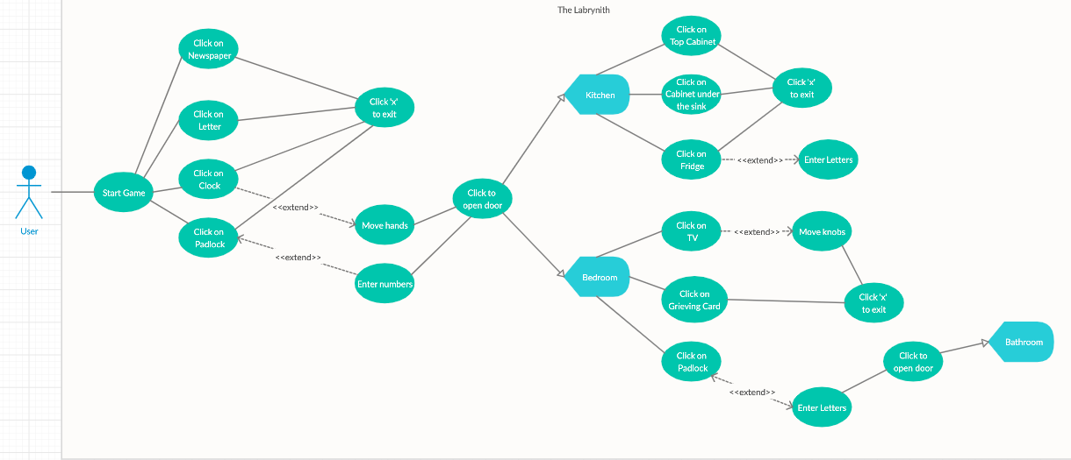

Within the living room:

* The user must be allowed to click on the newspaper, letter, clock, and padlock
  + The user must be able to click the 'X' to close out of the newspaper, letter, clock, and padlock interfaces
  + The user must be able to click and move the clock hands in the clock interface
    - The user must be able to click the right side door in the living room to enter the Kitchen once the clock is set to the correct time
  + The user must be able to click on the padlock to enter a passcode in the padlock interface
    - The user must be able to click on the center door in the living room to enter the Bedroom once the correct passcode is entered

Within the kitchen:

* The user must be able to click on the left side door, tall cabinets on the wall, the cabinet under the sink, and the fridge
  + The user must be able to click the left side door in the kitchen to enter the Living Room
  + The user must be allowed to click the 'X' to close out of the tall cabinets, sink cabinet, and the fridge interfaces
  + The user must be allowed to click on the fridge magnets to solve the anagram in the fridge interface.
    - The user must be given a hint when the anagram is solved

Within the bedroom:

* The user must be able to click on the left side door, television, grieving card, and keypad
  + The user must be able to click on the left side door in the bedroom to enter the Living Room
  + The user must be able to click the 'X' to close out of the television, grieving card, and keypad interfaces
  + The user must be allowed to click on the knobs while in the television interface.
    - The user must be able to click on the left door in the living room to enter the Loft once the knobs are set to the correct settings
  + The user must be allowed to click on the keypad buttons while in the keypad interface
    - The user must be able to click the right side door in the bedroom to enter the Bathroom once the correct word is entered into the keypad

# Class Diagram and/or Sequence Diagrams (15 points)

Class Diagram -

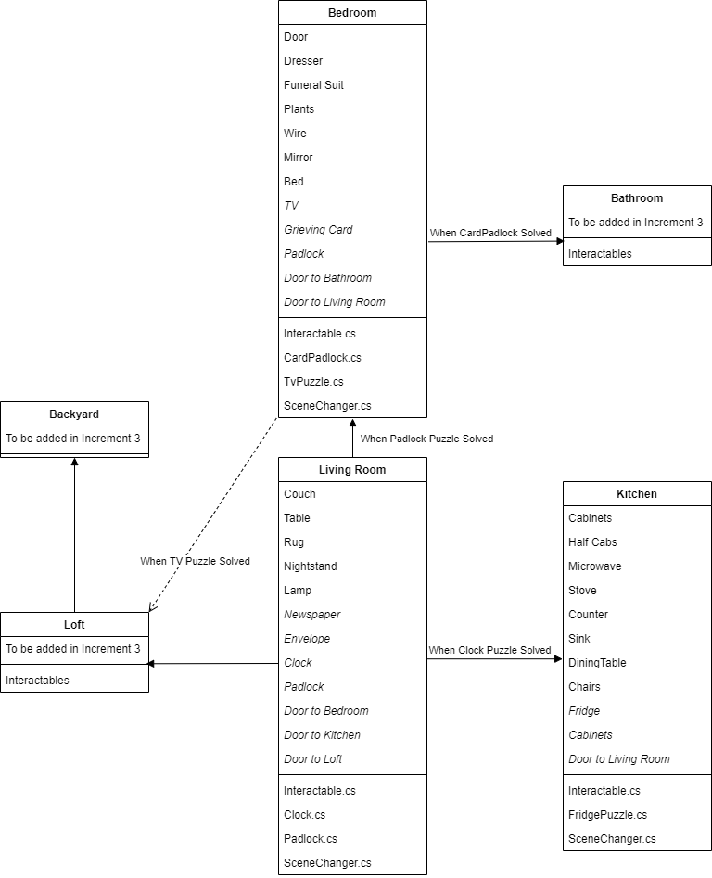

Sequence Diagrams -

Puzzle Solving

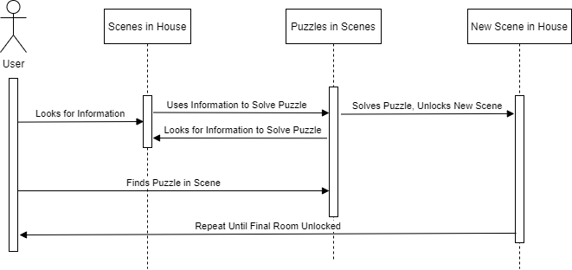

Scene Changing

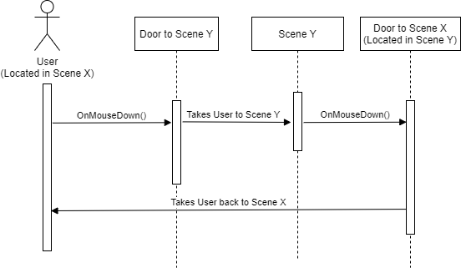

State Saving

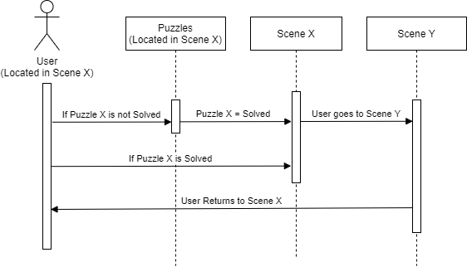

# Operating Environment (5 points)

The program will run on computers with Windows 10 installed. An internet connection will not be required to use the software. Since the program is self contained, it should not interfere with the operations of any other applications that may be concurrently running.

# Assumptions and Dependencies (5 points)

We assume that the end-user will have a Windows 10 machine capable of running a game with low-intensity assets. The machine does not have to be high end but it must be capable of displaying low graphics, as the art is not extremely detailed nor very demanding on the GPU. We expect the end-user to have an audio output device, either built into the machine or a speaker system.